Lab Manual

OOP
Laboratory 06:

Statement Purpose:
At the end of this lab, the students should be able to:
- Implement Arrays in Java
- Implement Control Structures in Java
- Use decision control structures (if, else, switch) which allows selection of specific sections of code to be executed
- Use repetition control structures (while, do-while, for) which allow executing specific sections of code a number of times
- Use branching statements (break, continue, return) which allows redirection of program flow

Arrays:
Arrays are special data types that let us store specified number of variables from the same type using one variable name.
Arrays are an indexed data type, which means they are storing different elements discriminating between them using unique index for each one. Figure shows the structure of an array.
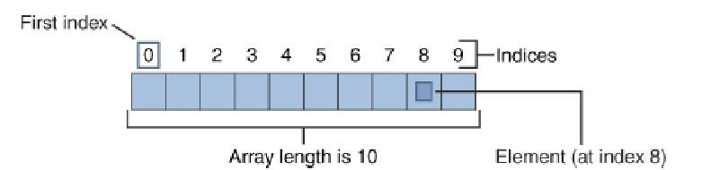
As Figure shows, the size of an array is fixed; we will refer to array maximum size as array length, it is also clear that indices of an array are zero-based, that is, they start from 0 to length –1; For example, the array shown in Figure has a length of 10 (stores up to 10 elements), and the last index is 9.
One-Dimensional Arrays in Java

Declaring and using an array in Java is similar to declaration of any variable; you have to specify data type and name, in addition to this, you have also to specify the length of the array before using it.

DataType arrayName[ ]; // Array declaration

To initialize the array, use new keyword and specify the length.
arrayName = new DataType[length]; // array creation

DataType array-variable[ ]= new DataType[length]; // Declaration and instantiation

Here are some examples of array declaration and creation:

int a[] = new int[6]; //Array of integers of length 6
String[] b = new String[10]; //Array of strings of length 10

To access array members, use array name with desired index specified between square brackets [].
int[] x = new int[3];
System.out.println(x[0]);
x[0] = 5; //Store 5 in the first index
x[1] = 10; //Store 10 in the second index
x[2] = 15; //Store 15 in the third index

System.out.println(x[2] + x[1]); //Prints 25

If you try to access an index out of the range of array (greater or equals array length) JVM will throw an IndexOutOfRangeException.

int[] x = new int[3]; //Valid indices are 0, 1 and 2
x[3] = 7; //IndexOutOfRangeException

Another technique to declare an array is to directly provide its members between brackets {}, separated using commas ',' that is called array initialization.

int x[] = {10, 15, 20, 25, 100}; //Length = 5
System.out.println(x[3]); //Prints 25

String[] days = {"Sat", "Sun", "Mon", "Tue", "Wed", "Thu", "Fri"};
System.out.println("We are leaving on " + days[2]);//We are leaving on Monday

Multidimensional Arrays (Arrays of Arrays)

Java also provides arrays of arrays, this means we create an array, and each element in that array is an array itself. These arrays are also called multidimensional arrays. The declaration of multidimensional arrays is shown below:

DataType arrayName[ ][ ]; // declaration
arrayName = new DataType[rows][columns] // array creation

DataType arrayName[ ][ ]= {{1,2,3},{4,5,6}} //array initialization with 2 rows and three columns

Example:

public class multidimensionalArray {
public static void main(String[] args) {
//declaring and initializing 2D array
int arr[][]={{1,2,3},{2,4,5},{4,4,5}};
//printing 2D array
for(int i=0;i<3;i++){
for(int j=0;j<3;j++){
System.out.print(arr[i][j]+" ");
}
System.out.println();
}
}
}
Output:
1 2 3
2 4 5
4 4 5

Control Structures:

A control structure allows us to change the ordering of how the statements in our programs are executed. There are two types of Control Structures

- Decision control structures :Allows to select specific sections of code to be executed
- Repetition control structures :Allows to execute specific sections of the code a number of times

Decision Control Structures:

A Java statement that allows us to select and execute specific blocks of code while skipping other sections.
- if-statement
- if-else-statement
- if-else if-statement
- switch statement

Example:1

//Demonstrate if-else-if statements.
public class ifelseExample {
public static void main(String[] args) {
int month=4;
String season;
if (month==12 || month==1 || month==2)
season="winter";
else if(month==3 || month==4 || month==5)
season="spring";
else if(month==6 || month==7 || month==8)
season="summer";
else if(month==9 || month==10 || month==11)
season="autumn";
else
season="Invalid Month";

System.out.println("April is in the " + season + ".");
}
}

Output:

Example:2
//A simple example of the switch
public class switchExample {
public static void main(String[] args) {
for(int i=0;i<6;i++)
switch(i){
case 0:
System.out.println("i is zero.");
break;
case 1:
System.out.println("i is one.");
break;
case 2:
System.out.println("i is two.");
break;
case 3:
System.out.println("i is three.");
break;
default:
System.out.println("i is greater than 3.");
}
}

}

Output:

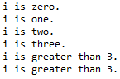
Repetition Control Structures:

Repetition control structures are a Java statement that allows us to execute specific blocks of code a number of times.
- while-loop
- do-while loop
- for-loop

Example:1
//demonstrate the while loop
public class whileExample {
public static void main(String[] args) {
int n=10;

while(n>0)
{
System.out.println("tick" +n);
n--;
}
}
}

Output:
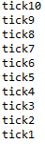
Example:2
//demonstrate the do-while loop
public class dowhileExample {
public static void main(String[] args) {
int n=10;
do{
System.out.println("tick" +n);
n--;
}while(n>0);

//the above loop can be more efficiently written as follows:
/*
do{
System.out.println("tick" +n);

}while(--n > 0);
*/
}
}

Output:


Example:3
//demonstrate for loop (loop control variable is declared inside the for)
public class forExample {
public static void main(String[] args) {
for (int n=10;n>0;n--)
System.out.println("tick" +n);
}
}

Output:


Branching Statements

Branching statements allows us to redirect the flow of program execution. Java offers three branching statements:

- break
- continue
- return.

Example:1
//Using break with nested loops
public class breaknested {
public static void main(String[] args) {
for(int i=0;i<3;i++)
{
System.out.print("Pass" +i+ ":");
for(int j=0;j<100;j++)
{
if(j==10) break;
System.out.print(j + " ");
}
System.out.println();
}
System.out.println("Loops complete. ");
}
}
Output:
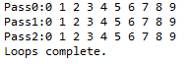
Example:2
//Demonstrate continue
public class continueExample {
public static void main(String[] args) {
for(int i=0;i<10;i++)
{
System.out.print(i + " ");
if(i%2 == 0) continue;

System.out.println("");
}
}
}

Output:

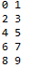
Example:3
//Demonstrate return
import java.util.Scanner;

public class returnExample {
public static void main(String[] args) {
int num1, num2;
Scanner data = new Scanner(System.in);

System.out.println("Enter 1st number");
num1 = data.nextInt();
System.out.println("Enter 2nd number");
num2 = data.nextInt();
data.close();
total(num1,num2);
}

public static void total(int numx, int numy){
int sum=0;
sum=numx+numy;
if(sum==0)
return ;
System.out.println("Sum of 2 number:"+sum);

}

}
Output:

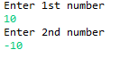
Output:
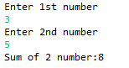

Lab Tasks:

Task 1: Write a Java application that uses looping to print the following table of values:
Marks: 3

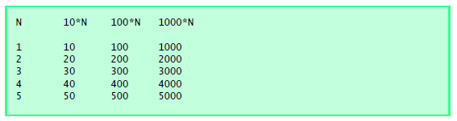

Task 2: Write a program using while loop which calculate square of every number and then sum the squares of all numbers. Output should be like as shown below: Marks: 3

Output:

1
4
9
16
25
36
49
64
81
100
Total is 385

Task 3: Write a test program that takes some values from user and stores in an array, and finds out the minimum value from an array. Marks: 3
Task 4: What does the following program print? Marks: 1

public class task3 {
public static void main(String[] args) {
int count = 1;
while ( count <= 10 ) {
System.out.println( count % 2 == 1 ? "****" : "++++++++" );
++count;
}
}
}

